

Foundations of Programming

Assignment No.: 18
PROBLEM STATEMENT: Write a C program that accepts a string from the user and performs the following string operations: i) Calculate length of string ii) String reversal iii) Equality check of two strings iv) Check palindrome v) Check substring.

OBJECTIVE:

- To understand basic string operations in C.
- To learn how to manipulate strings using loops and functions.
- To perform comparison, reversal, and substring checking.
- To check whether a string is a palindrome.

THEORY:
In C programming, a string is a sequence of characters terminated by a null character ('\0'). Strings are commonly stored in character arrays. Various operations can be performed on strings such as calculating their length, reversing the characters, comparing two strings, checking whether a string is a palindrome, and finding a substring within another string. These operations can be implemented using loops and conditional statements or by using standard library functions from the string.h header file.
PLATFORM: Linux

INPUT: A string and another string for comparison and substring checking.

OUTPUT: Displays string length, reversed string, equality result, palindrome result, and substring check result.

CODE:
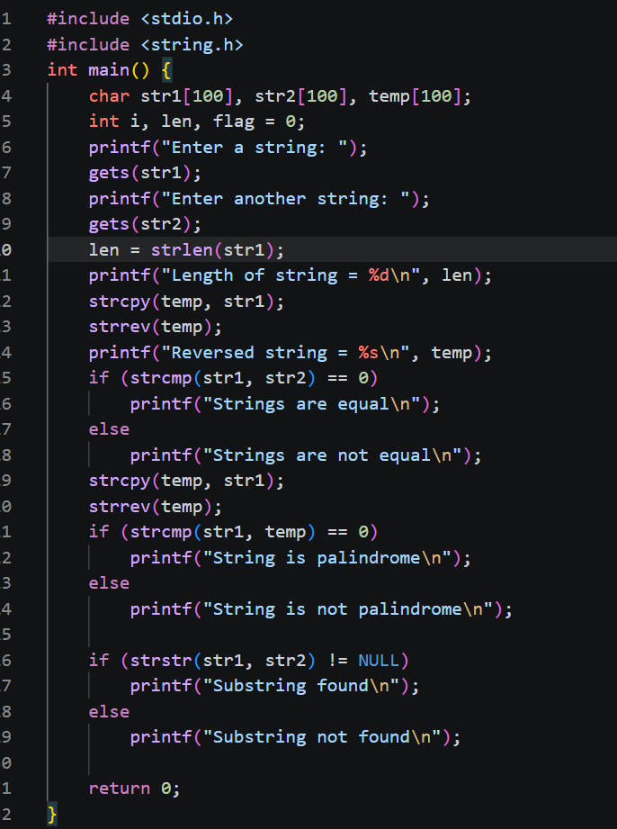

SAMPLE INPUT:

Enter a string: madam
Enter another string for equality check: mad
SAMPLE OUTPUT:
Length of string = 5
Reversed string = madam
The string is a Palindrome
Strings are not equal
Substring found in main string

CONCLUSION: Thus, the C program successfully performs different string operations such as length calculation, reversal, equality check, palindrome check, and substring detection.

FAQs:
- What is a string in C programming?
Soln: A string in C programming is a sequence of characters stored in an array and terminated by a special null character '\0'. It is used to represent text such as words or sentences, and is typically declared as a character array like char str[100];.
- Which header file is required for string functions?
Soln: The header file required for string functions in C is <string.h>, which provides functions like strlen(), strcpy(), strcmp(), and strcat().
- What function is used to find the length of a string?
Soln: The function used to find the length of a string in C is strlen(), which is defined in the <string.h> header file.
- What is a palindrome string?
Soln: A palindrome string is a string that reads the same forward and backward. For example, words like “madam”, “level”, and “radar” are palindrome strings because their reverse is identical to the original.
- Which function is used to check a substring in C?
Soln: The function used to check a substring in C is strstr(), which is defined in the <string.h> header file. It searches for the occurrence of one string inside another and returns a pointer if found, otherwise NULL.

